[1]

Computer vision using Cloud

Allen Miller - [allenmiller@mail.smu.edu](mailto:allenmiller@mail.smu.edu), David Grijalva - [dgrijalva@mail.smu.edu](mailto:dgrijalva@mail.smu.edu)  
Mingyang Nick YU - [nyu@mail.smu.edu](mailto:nyu@mail.smu.edu), Venkata MG Vanga - [mvanga@mail.smu.edu](mailto:mvanga@mail.smu.edu)

*Abstract* — In today’s world, the increasing computational power provides the ability to use the device cameras to detect objects. This paper combines the capability of cloud technologies with the coding techniques to achieve computer vision. A web application is created and trained such that the application detects the objects in field of camera. The web application is launched using the cloud platform which is scalable and adaptable based on the application.

*Index Terms* — object detection, cloud, computer vision

# INTRODUCTION

C

omputer vision has been in existence since 1960’s [1], by definition it means how the computers can be made to understand digital images or videos and how they can interpret them [2]. The increased computational power of the personal computers made the idea of computer vision possible using the webcams. In this paper we use the python ‘YOLO’ neural network model [5]. YOLO is a single neural network model that detects the objects by dividing the image or video into specific bounding boxes [4]. YOLO then treats spatially separated bounding boxes for object detection as a regression problem to associate the class probabilities. In this paper YOLO code is deployed using the FLASK app which is loaded into the cloud platform.

# Abbreviations and Acronyms

AWS – Amazon Web Services

EC2 – Elastic Compute Instance

GCP – Google Cloud Platform

YOLO - You Only Look Once

# Methodology and Training

Below are few snapshots that are taken using the YOLO model. Fig. 1 shows both chair and sports ball as detectable objects where are Fig. 2 and Fig. 3 only detects the chair and the toy and rubic’s cube are not detected. These objects which are not detected are to trained and tested again for application testing.

Fig 1. Chair and Sports Ball.

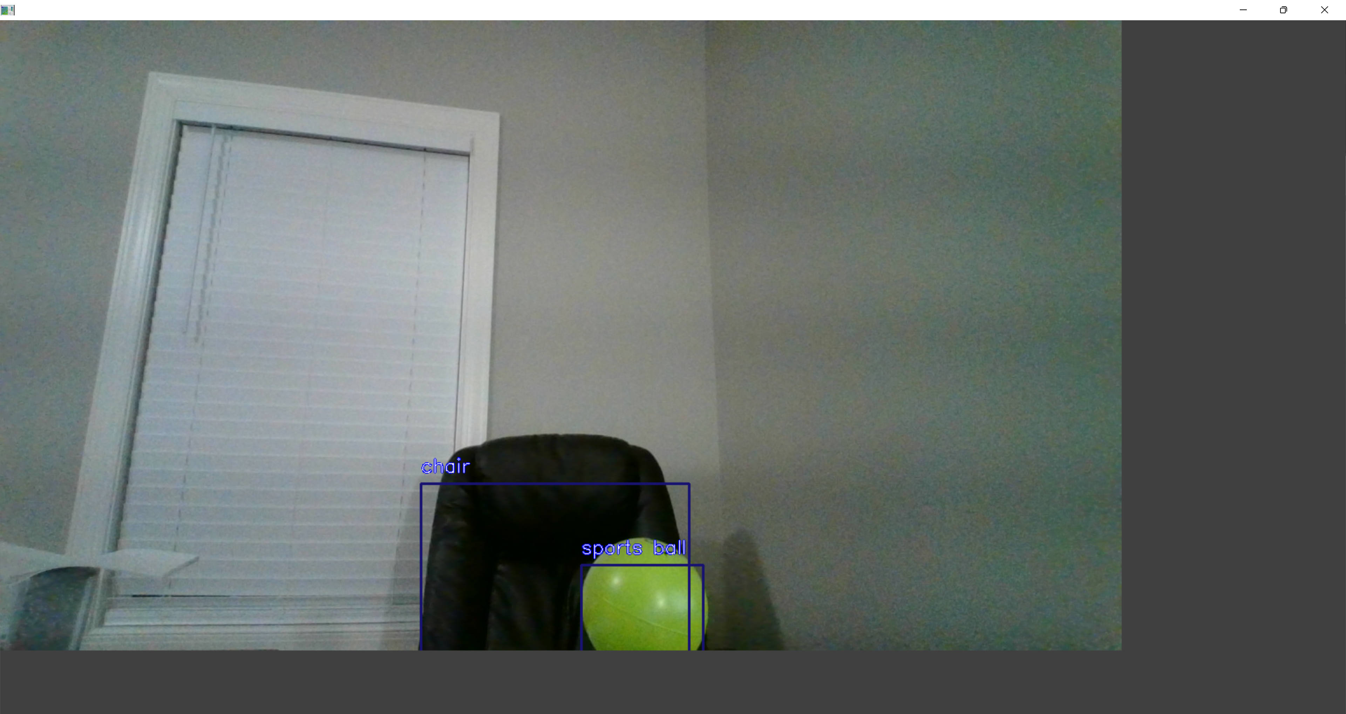

Fig2. Chair and Toy.

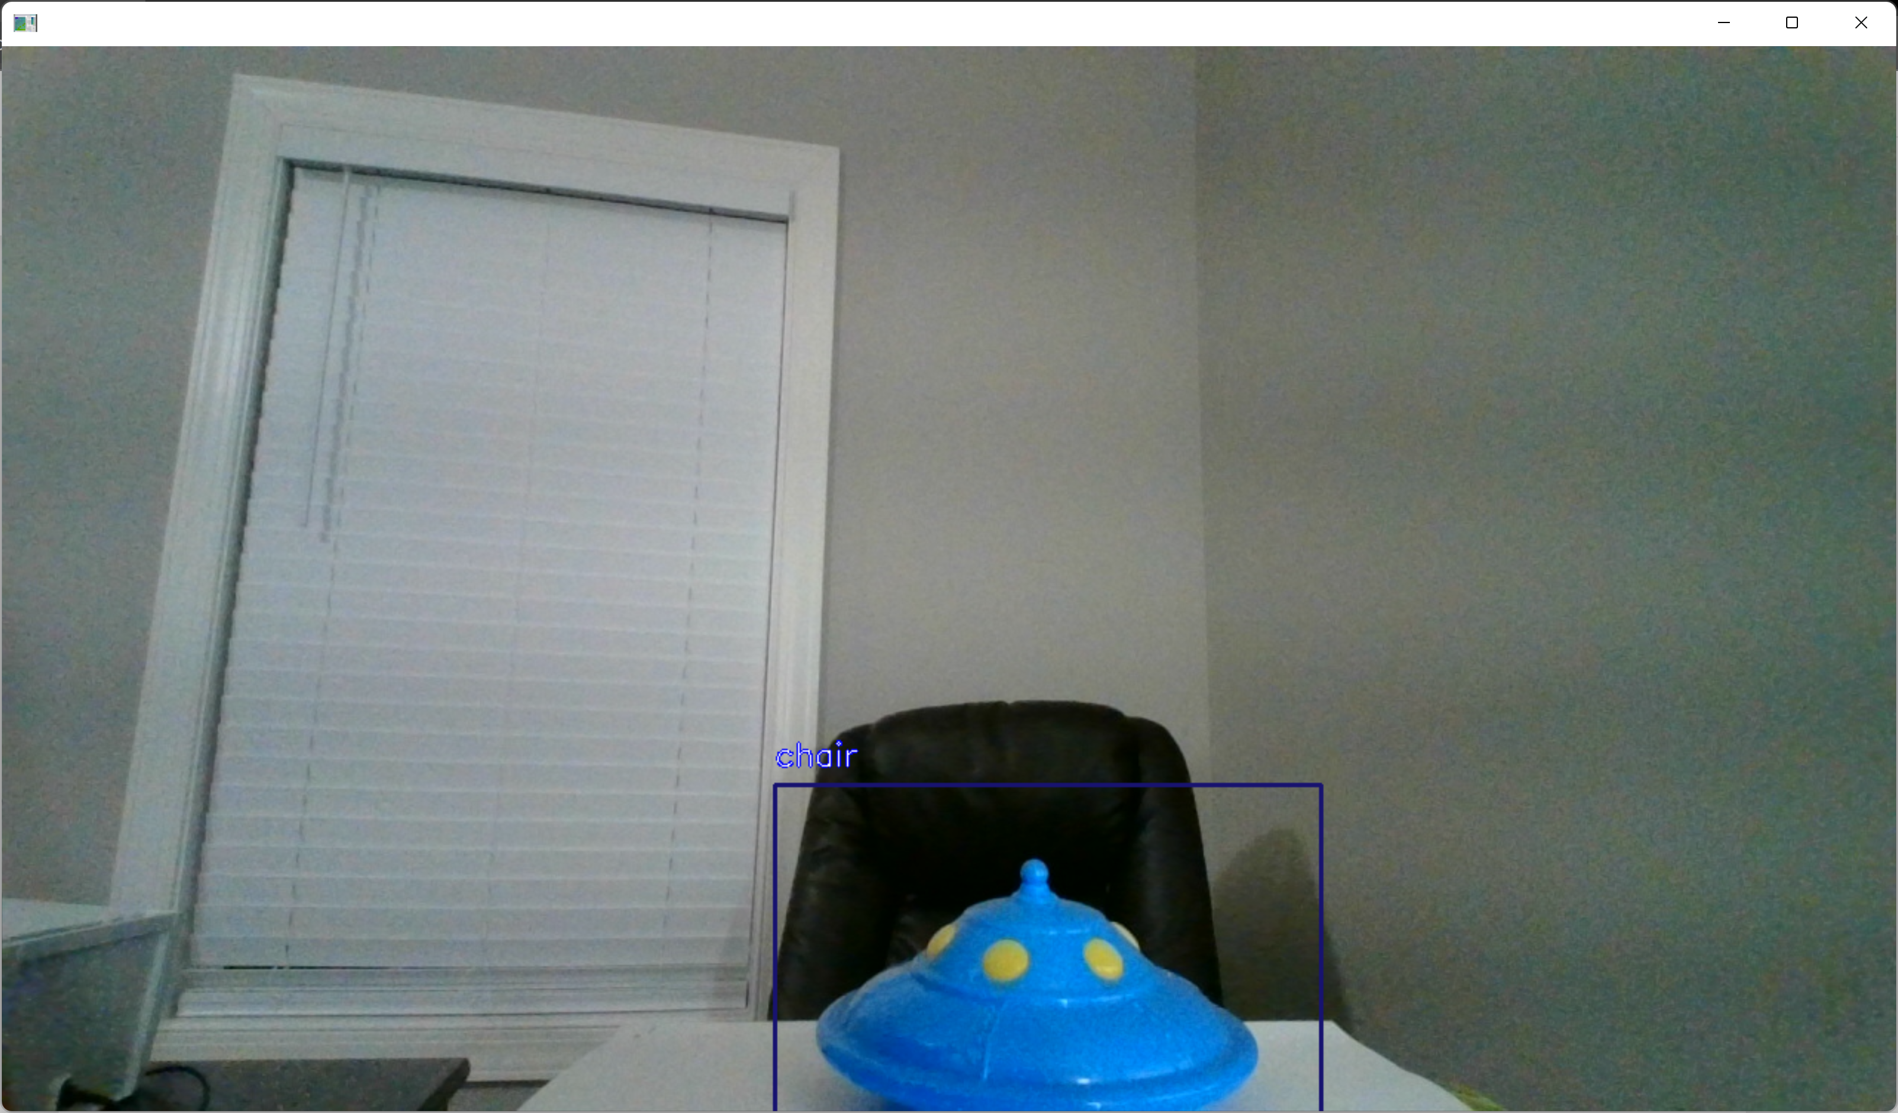

Fig 3. Chair and Rubic’s Cube.

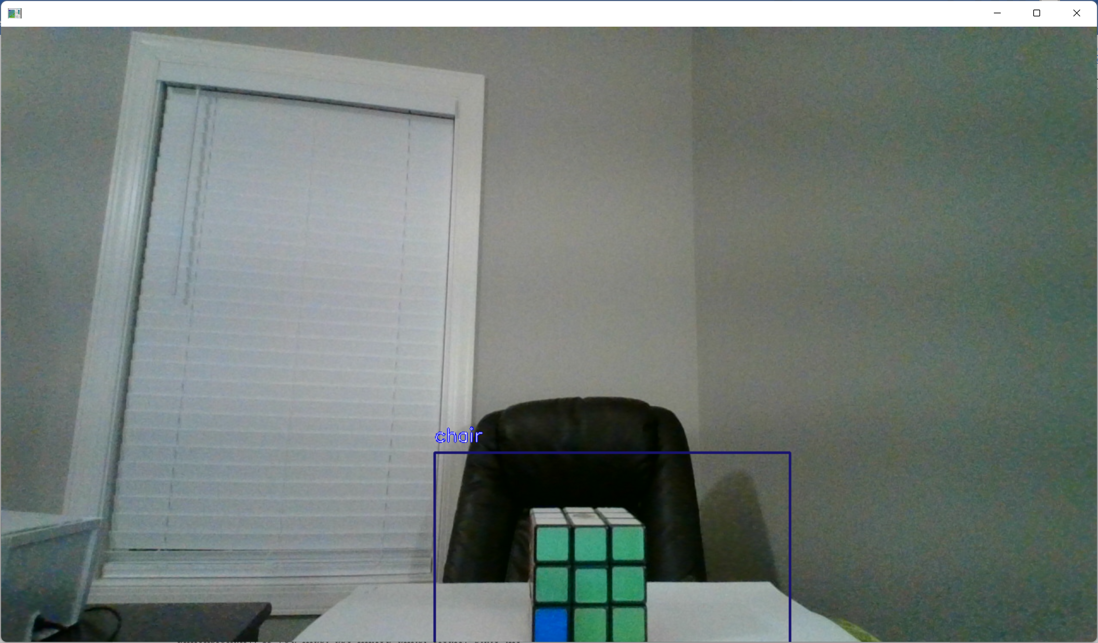

# Discussion

## The trained model can be used for multiple object detection in a single image or video. The future applications are limitless and a few are listed below:

i. Self-driving vehicles.

ii. Robot navigation.

iii. Multi object detection helping Astro-physicists.

iv. Neurobiology

The deployed web app is scalable and adaptable and can be used to train multiple objects.

Place Holder to add more.

# Conclusion

## Place Holder to add more.

Appendix

References

1. Dana H. Ballard; Christopher M. Brown (1982). Computer Vision. Prentice Hall. ISBN 978-0-13-165316-0.
2. https://en.wikipedia.org/wiki/Computer_vision.
3. https://towardsdatascience.com/how-to-detect-objects-with-your-webcam-82693c47bd8.
4. Redmon, J., Divvala, S., Girshick, R., & Farhadi, A. (2016). You only look once: Unified, real-time object detection. In Proceedings of the IEEE conference on computer vision and pattern recognition (pp. 779-788).
5. https://docs.aws.amazon.com/sagemaker/latest/dg/object-detection.html.
6. https://docs.aws.amazon.com/sagemaker/latest/dg/realtime-endpoints.html.
7. https://www.twilio.com/blog/deploy-flask-python-app-aws.

1.